 

**ASMAA FATIMA- 8219552**

**MOHAMMAD BAKHEET- 7449148**

**YOUSSEF MANSI- 8221376**

**ZAID KHAN- 6735459**

**GROUP PROJECT- WINTER 2024**

**CSIT127 – NETWORKS AND COMMUNICATIONS**

**GROUP PROJECT- WINTER 2024**

Z xzx

INDEX

|  |  |  |
| --- | --- | --- |
| **Serial No.** | **Topic** | **Page No.** |
|  | Project objective | 2 |
|  | Introduction | 3 |
|  | Network topology | 4 |
|  | Networking equipment | 5 |
|  | Departmental requirements | 6 |
|  | Calculations for identifying our subnet ranges | 7 |
|  | IT department | 7 |
|  | Procurement department | 8 |
|  | Staff | 9 |
|  | HR department | 10 |
|  | Complete Network Overview | 11 |
|  | Details of IP Addressing | 12 |
|  | Conclusion | 13 |
|  | References | 14 |

**PROJECT OBJECTIVE**

The purpose and objective of this project is to apply the concepts we have learned during the Winter 2024 semester to design and simulate a networking solution for a new business. Opening fresh branches of operation, our network engineering team is in charge of designing a suitable communication network for the industrial scenario we have chosen. While designing the network, we are to propose any innovative ideas that we have come up with and incorporate professional practices and standards in our work (e.g., competency and ethics).

**Our team is responsible for:**

1. Determine the type/number of networking equipment required to meet the operational requirements of the new office.

2.Mention the networking topology for the new organizational network. Divide the network into an appropriate number of subnets and design an addressing scheme for your network and subnets (picking any suitable IP address for the big network).

**INTRODUCTION**

We are a **network engineering team,** **CareLink Solutions** and we will be overseeing the designing of a suitable communication network for a healthcare office for our **client, Mr.Mayz.** The name of our **proposed hospital is Zaym** Hospital, and we have four departments in the industry, namely IT Department, Procurement Department, HR Department and Staff.

The **network topology** we have proposed for this hospital is **star topology** and we have showed a representation and description of it in this report. We have written the advantages and disadvantages of choosing this topology and the networking equipment we have incorporated in the infrastructure of the network.

Additionally, we have included our proposed network addressing scheme, and a detailed explanation and **representation** of it using a visual network simulation tool, **Cisco Packet Tracer** that allows users to imitate modern computer networks and create simple and complex network topologies.

**REPORT**

**Network topology** refers to the physical or logical arrangement of nodes (such as computers, switches, routers, or other devices) and the connections between them in a computer network. (KEARY, 2024)

**The Blueprint of a Network**in simple terms is the network topology or map of the network. It outlines the layout and structure of the network, showing how the devices are interconnected and how data is transmitted between them. It defines the paths that information takes from one node to another and influences the efficiency, scalability, and reliability of the network.

By understanding the role of topology in network management, network administrators and engineers can plan, manage, and troubleshoot the network effectively. It helps us identify potential bottlenecks, optimize performance, and ensure reliable communication between devices. (KEARY, 2024)

**There are different types of network topologies**, including: Bus, Star, Ring, Mesh, Tree, Hybrid (KEARY, 2024). In our networking/communication infrastructure design we have proposed star topology.

**Star topology** is a [network topology](https://www.techopedia.com/definition/5538/network-topology) in which each network component is physically connected to a central node such as a router, hub or switch.

The central hub acts like a server and the connecting nodes act like clients. When the central node receives a [packet](https://www.techopedia.com/definition/5380/packet) from a connecting node, it can pass the packet on to other nodes in the network. (Rouse, Star Topology, 2023)

**We chose star topology because:**

* its reliable. If one cable or device fails, then all the others still work.
* ease of managing it from one point
* it has high performance as no data collisions can occur.
* its less expensive because each device only needs one Input/Output port and wishes to be connected with the hub with one link.
* its robust in nature
* there are no disruptions to the network when connecting or removing devices
* its durable.
* it has low cable usage
* there’s ease in lining it up.

**Networking Equipment:**

**Also knows as network hardware is a set of physical or network devices that are essential for interaction and communication between hardware units operational on a computer network. These are dedicated hardware components that connect to each other and enable a network to function effectively and efficiently.** (Kanade, n.d.)

**Here is our networking equipment table:**

|  |  |
| --- | --- |
| **Equipment** | **Description** |
| **Routers:** | A router connects two or more networks. One common use of the router is to connect a home or office network ([LAN](https://www.spiceworks.com/tech/networking/articles/what-is-local-area-network/)) to the internet (WAN). It generally has a plugged-in internet cable along with cables that connect computers on the LAN. Alternatively, a LAN connection can also be wireless (Wi-Fi-enabled), making the network device wireless. These are also referred to as wireless access points (WAPs). (Kanade, n.d.) |
| **Switch** | A switch is a multiport bridge with a buffer and a design that can boost its efficiency(a large number of ports imply less traffic) and performance. A switch is a data link layer device. The switch can perform error checking before forwarding data, which makes it very efficient as it does not forward packets that have errors and forward good packets selectively to the correct port only. (Network Devices , n.d.) |
| **Network cable** | Network cable are connections used in [telecommunications](https://www.smartcapitalmind.com/what-is-telecommunications.htm) and enable us to connect various devices and relay data from device to device. |
| **Access Point** | A [wireless access point (WAP)](https://www.cisco.com/c/en/us/solutions/small-business/networking/wireless.html) is a networking device that allows wireless-capable devices to connect to a wired network. |

After reviewing our project goals and objectives, we established the subnet address as 192.168.1.0 to serve as the backbone of our network infrastructure.

**Here’s a breakdown of our departmental requirements:**

|  |  |
| --- | --- |
| **Department/ Branch Name** | **No. of hosts** |
| IT Department | 35 |
| Procurement Department | 15 |
| HR Department | 30 |
| Staff | 20 |

When determining the range of IP addresses for a network, it's essential to start with the largest number of hosts because the size of the IP address range is directly related to the number of hosts required.

**The main reasons are:**

1. **Address Space Allocation:** IP addresses are allocated in blocks of varying sizes, depending on the specific number of hosts needed. The larger the number of hosts required, the larger the block of IP addresses needed.
2. **Efficient Allocation:** Starting with the largest number of hosts ensures that we can allocate enough address space to accommodate all potential hosts. It prevents situations where we might run out of available IP addresses.
3. **Subnetting:** Starting with the largest number of hosts allows us to subnet the network efficiently, ensuring that each subnet has enough addresses to support our host requirements.

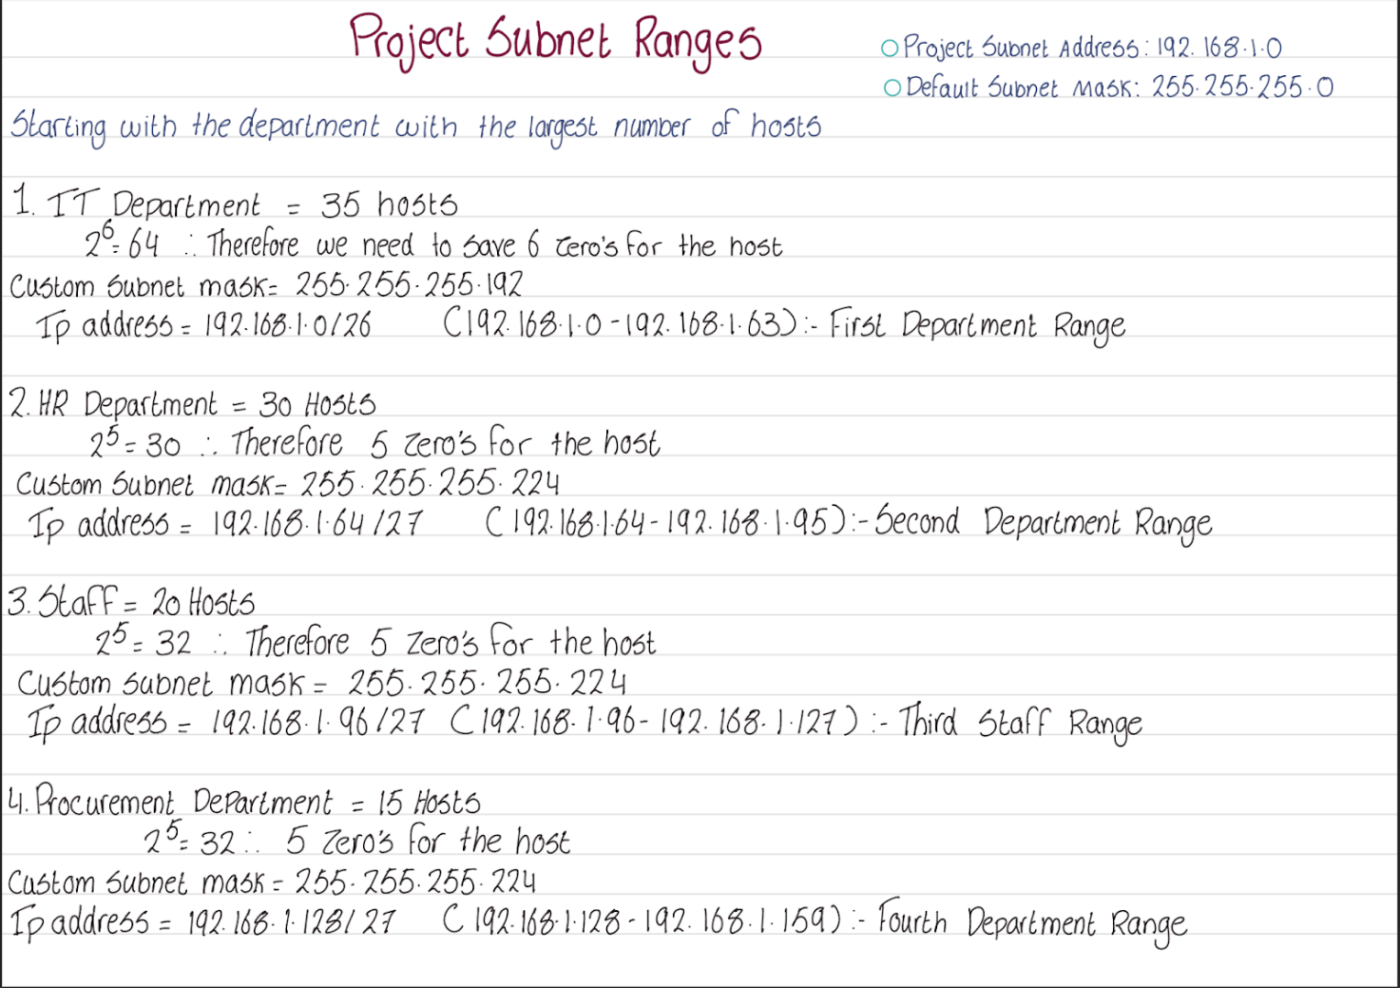**Here are our calculations for identifying our subnet ranges:**

**IT Department:**

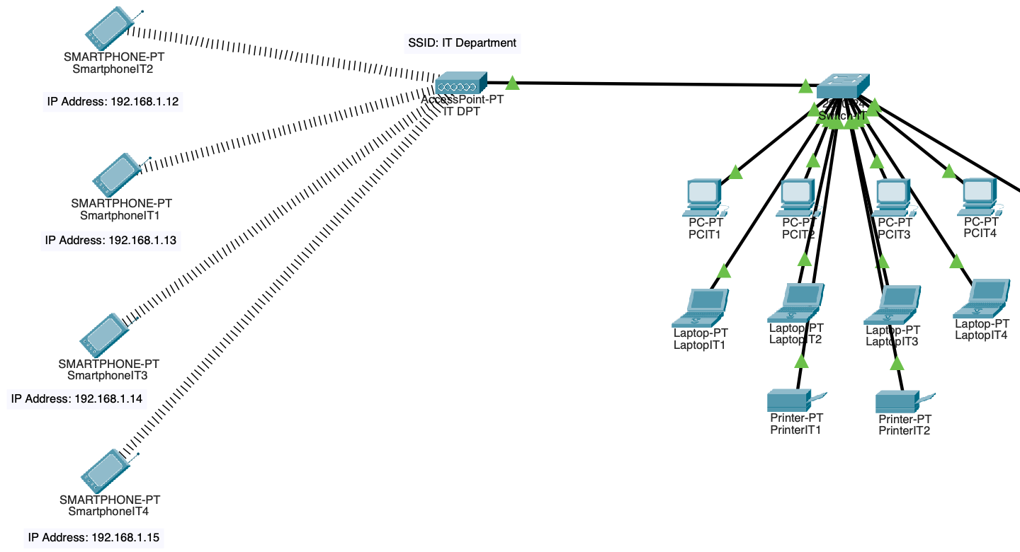

This is our IT Department, the innovative hub of our network, showcasing a default gateway at 192.168.1.1. As the first department, it accommodates the largest host count with 35 hosts. Operating within a subnet range of 192.168.1.0 to 192.168.1.63, this department comprises 10 wired devices and 4 wireless smartphones, ensuring smooth connectivity and productivity

The screenshot below vividly illustrates bi-directional communication showing how each wired device smoothly exchanges messages with every wireless device and vice versa.

**Procurement Department:**

This is the Procurement Department our network infrastructure is designed to ensure seamless connectivity and productivity. Our devices are connected through a default gateway (192.168.1.129). We use an access point for four devices: two printers, one laptop, and one smartphone. Additionally, we have a switch connecting eight PCs. The subnet range for this department is (192.168.1.128 - 192.168.1.159)

Our network infrastructure ensures flawless communication among all devices within the procurement department. Through the exact configuration of IP addresses and subnet masks, both wired and wireless devices establish reliable connections, facilitating efficient data transmission and collaboration. This organized setup enables smooth communication between wired and wireless devices, ensuring that messages and data flow effortlessly across our network.

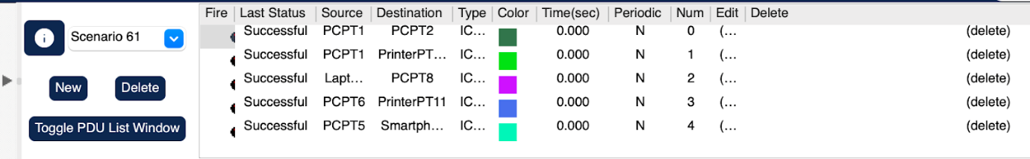

Displayed above are the data transmissions among devices within the procurement department, and the successful exchange of data as devices communicate effortlessly with one another.

**Staff department:**

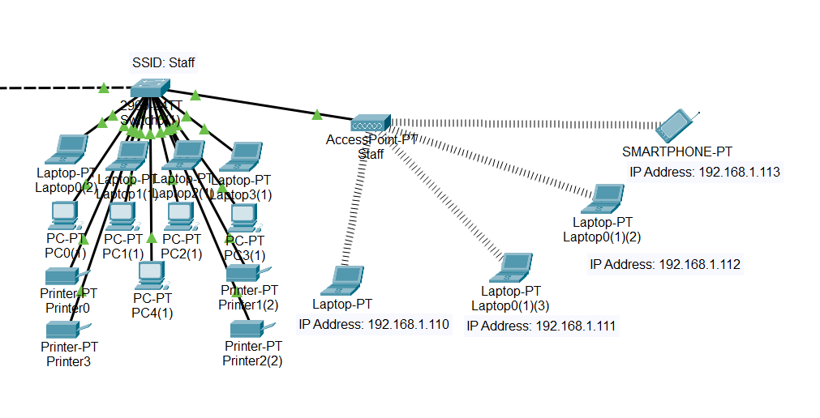

This is a screenshot for the staff working in the branches, which consists of 17 end devices, 13 of them are wired and they are wireless with the IP address range of (192.168.1.96 - 192.168.1.127).

A screenshot of the file messages status for the Staff branch, which is successful.

For the Context, this is a real-time scenario, a real-life time simulation of the networking systems for the Cisco Packet tracer. We sent a message from one device to another to check the connectivity for our machines, Which was successful as shown in the screenshot above, the reason behind it is that they all share the same default gateway.

**HR Department:**

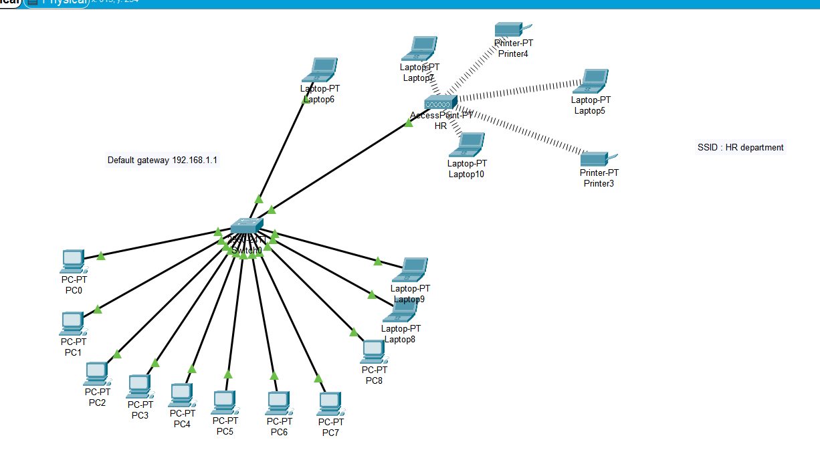

This is a screenshot of our HR department. Out of the 17 devices, 5 were wireless and the rest were wired. We also used a different range of devices like PC, laptop , and printers as that is what we think the real department would need. We also had specific IP address ranges for each department. The range for the HR department was 192.168.1.64 - 192.168.1.95.

We also tested each device to make sure they are all connected with each other. This small screenshot here shows that the wired devices can communicate with other wired devices , wireless devices can communicate with wireless devices and that wired devices can communicate with wireless devices.

**And here is a screenshot of the complete network for a final overview:**



**The screen shots above illustrate the successful connectivity and message transmission of both wired and wireless devices from each department through the router.**

**Here are the details of our IP Addressing and other network specifications:**

|  |  |  |  |  |
| --- | --- | --- | --- | --- |
| **Departments** | **IT Department** | **Procurement Department** | **HR Department** | **Staff** |
| **Department ranges** | (192.168.1.0 -192.168.1.63) | (192.168.1.128 -192.168.1.159) | (192.168.1.64 -192.168.1.95) | (192.168.1.96 -192.168.1.127) |
| **Address class** | C | C | C | C |
| **Default subnet mask** | 255.255.255.0 | 255.255.255.0 | 255.255.255.0 | 255.255.255.0 |
| **Total number of subnets** | 2^6 | 2^5 | 2^5 | 2^5 |
| **Total number of hosts** | 35 Hosts | 15 Hosts | 30 Hosts | 20 Hosts |
| **Number of usable hosts** | 33 Hosts | 13 Hosts | 28 Hosts | 18 Hosts |
| **Custom subnet mask** | 255.255.255.192  /26 | 255.255.255.224  /27 | 255.255.255.244  /27 | 255.255.255.244  /27 |
| **Number of bits borrowed from the host** | 2 Bits borrowed from the host | 3 Bits borrowed from the host | 3 Bits borrowed from the host | 3 Bits borrowed from the host |
| **IP address (decimal)** | 192.168.1.0/26 | 192.168.1.64/27 | 192.168.1.96/27 | 192.168.1.128/27 |
| **IP address (binary)** | 11000000.  10101000.  00000001.  00000000 | 11000000.  10101000.  00000001.  01000000 | 11000000.  10101000.  00000001.  01100000 | 11000000.  10101000.  00000001.  10000000 |
| **IP address ranges** | 192.168.1.0 - 192.168.1.63 | 192.168.1.64 - 192. 168.1.95 | 192.168.1.96 - 192.168.1.127 | 192.168.1.128 - 192.168-1.159 |
| **Subnet IP address** | 192.168.1.0 | 192.168.1.128 | 192.168.1.64 | 192.168.1.96 |
| **First IP address** | 192.168.1.1 | 192.168.1.129 | 192.168.1.65 | 192.168.1.97 |
| **Last IP address** | 192.168.1.62 | 192.168.1.158 | 192.168.1.94 | 192.168.1.126 |
| **Broadcast IP address** | 192.168.1.63 | 192.168.1.159 | 192.168.1.95 | 192.168.1.127 |

**CONCLUSION**

For our client, Mr.Mayz, our network engineering team, CareLink Solutions has proposed a suitable communication network for the healthcare office, Zaym Hospital.

In our intensive network validation process, each department - IT Department, Procurement Department, HR Department and Staff- conducted an in-depth testing to ensure the robustness of our network infrastructure.

Using a combination of wired and wireless devices, we transmitted messages to the router, carefully verifying connectivity and reliability across the entire spectrum of our network. This exhaustive testing routine shows our commitment to maintaining a high-performing network environment, capable of meeting the diverse communication needs of Zaym Hospital.

# **REFERENCES**

1. *Advantages and Disadvantages of Hybrid Topology*. (2023, July 18). From https://www.geeksforgeeks.org/advantages-and-disadvantages-of-hybrid-topology/?ref=ml_lbp
2. Kanade, V. (n.d.). *What Is Network Hardware?* From https://www.spiceworks.com/tech/networking/articles/what-is-network-hardware/
3. KEARY, T. (2024, January 10). *Network Topology: 6 Network Topologies Explained & Compared*. From https://www.comparitech.com/net-admin/network-topologies-advantages-disadvantages/
4. *Network Devices* . (n.d.). From https://www.geeksforgeeks.org/network-devices-hub-repeater-bridge-switch-router-gateways/
5. Rouse, M. (2023, December 14). *Mesh Networking*. From https://www.techopedia.com/definition/24398/mesh-networking
6. Rouse, M. (2023, June 28 ). *Star Topology*. From https://www.techopedia.com/definition/13335/star-topology